Computer vision 1

Homework 9

姓名 ： 蘇宛琳

系所 ： 電信所碩一

學號 ： R05942060

指導教授 ： 傅楸善老師

Computer Vision Report – Homework 9

R05942060 蘇宛琳

Question :

Write programs to generate the following gradient magnitude images and choose proper thresholds to get the binary edge images:

1. Roberts operator
2. Prewitt edge detector
3. Sobel edge detector
4. Frei and Chen gradient operator
5. Kirsch compass operator
6. Robinson compass operator
7. Nevatia-Babu 5X5 operator

**\* Roberts operator Concept \***

When processing the gradient image, there should be a value which you used for zero crossing. -> Roberts operators with threshold 10 : two 2X2 masks to calculate gradient

利用每點影像的像素值和 mask 分別相乘，達到邊緣偵測的結果值，在依照 gradient 定義把影像值寫回入新的影像矩陣中。利用『im2double』將原本 Lena 影像中的每點像素轉換成 doubles，方便和 mash 數值做運算。最後的 threshold 判斷將影像變成『二值化』的步驟即可求得最後結果。

**Source code**

function robert=RobertOperator(image,threshold)

image=imread('lena.bmp');

b=im2double(image);

[m,n]=size(image);

newimage_robert=zeros(size(image));

threshold=10;

L(1:m,1:n)=0;

for i=1:m-2;

for j=1:m-2;

r1=-1*b(i,j)+0+0+1*b(i+1,j+1);

L(i,j)=r1*r1;

end

end

M(1:m,1:n)=0;

for i=1:m-2;

for j=1:m-2;

r2=0-1*b(i,j+1)+1*b(i+1,j)+0;

M(i,j)=r2*r2;

end

end

for i=1:m-2;

for j=1:m-2;

gradient =sqrt(L(i,j)+M(i,j));

newimage_robert(i,j)= gradient;

end

end

figure;

imshow(newimage_robert);

imwrite(newimage_robert,'robert1.bmp')

figure;

robert=imread('robert.bmp');

[m,n]=size(robert);

for i=1:m

for j=1:n

if robert(i,j)>threshold

robert(i,j)=0;

else

robert(i,j)=1;

end

end

end

imshow(uint8(robert)*255);

imwrite(uint8(robert)*255,'robert_thres.bmp')

end

**Result**

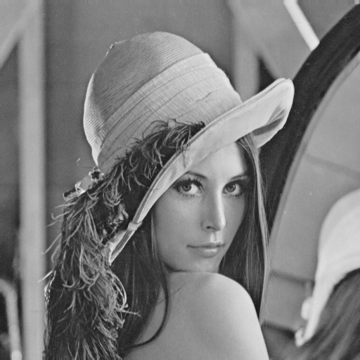 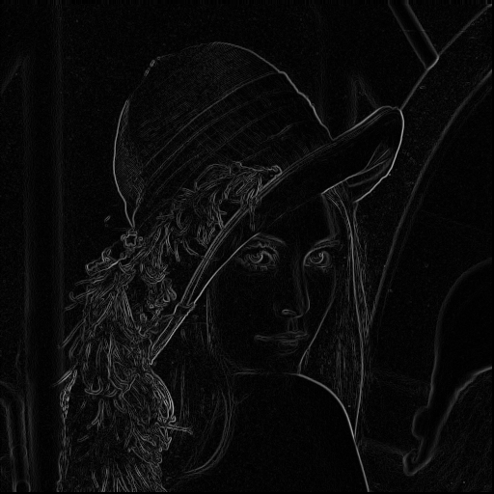

Edge operator

Original image Edge image

利用threshold = 10

來取得二值化影像。

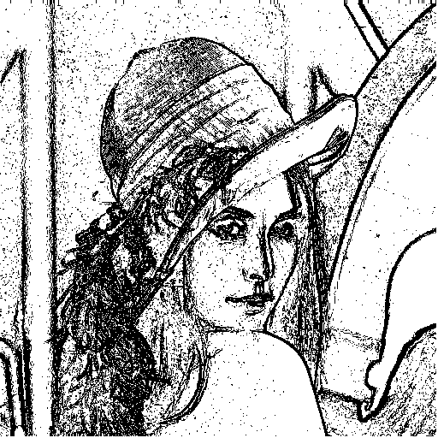

Robert's Operator Edge image

**\* Prewitt edge detector Concept \***

When processing the gradient image, there should be a value which you used for zero crossing. -> Prewitt edge detector with threshold 25 : two 3X3 masks in row column direction

利用每點影像的像素值和 mask 分別相乘，達到邊緣偵測的結果值，在依照 gradient 定義把影像值寫回入新的影像矩陣中。利用『im2double』將原本 Lena 影像中的每點像素轉換成 doubles，方便和 mash 數值做運算。最後的 threshold 判斷將影像變成『二值化』的步驟即可求得最後結果。這裡和上一個 operator 不一樣的地方為:此 為 3*3 矩陣。因此要修改矩陣的大小即可。

**Source code**

function prewitt=PrewittOperator(image,threshold)

image=imread('lena.bmp');

b=im2double(image);

[m,n]=size(image);

newimage_robert=zeros(size(image));

threshold=25;

L(1:m,1:n)=0;

for i=1:m-3;

for j=1:m-3;

r1=-1*b(i,j)+-1*b(i,j+1)+-1*b(i,j+2)+0+0+0+1*b(i+2,j)+1*b(i+2,j+1)+1*b(i+2,j+2);

L(i,j)=r1*r1;

end

end

M(1:m,1:n)=0;

for i=1:m-3;

for j=1:m-3;

r2=-1*b(i,j)+0+1*b(i,j+2)-1*b(i+1,j)+0+1*b(i+1,j+2)-1*b(i+2,j)+0+1*b(i+2,j+2);

M(i,j)=r2*r2;

end

end

for i=1:m-3;

for j=1:m-3;

gradient =sqrt(L(i,j)+M(i,j));

newimage_robert(i,j)= gradient;

end

end

figure;

imshow(newimage_robert);

imwrite(newimage_robert,'prewitt.bmp')

figure;

prewitt = imread('prewitt.bmp');

[m,n]=size(prewitt);

for i=1:m

for j=1:n

if prewitt(i,j)>threshold

prewitt(i,j)=0;

else

prewitt(i,j)=1;

end

end

end

imshow(uint8(prewitt)*255);

imwrite(uint8(prewitt)*255,'prewitt_thres.bmp')

end

**Result**

 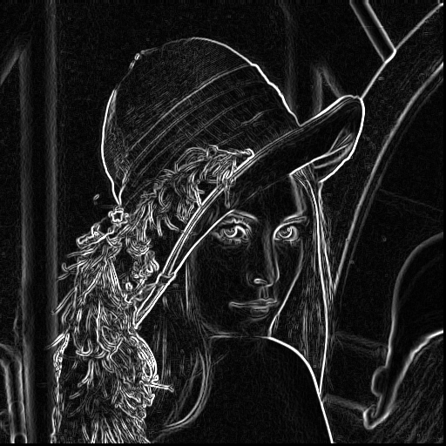

Edge operator

Original image Edge image

利用threshold = 25

來取得二值化影像。

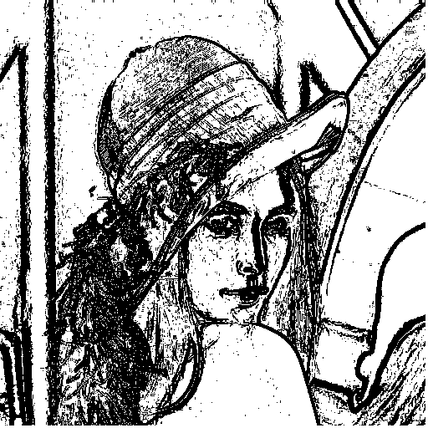

prewitt's Operator Edge image

**\* Sobel's Edge Detector Concept \***

When processing the gradient image, there should be a value which you used for zero crossing. -> Sobel’s edge detector with threshold 36 : two 3X3 masks in row column direction

利用每點影像的像素值和 mask 分別相乘，達到邊緣偵測的結果值，在依照 gradient 定義把影像值寫回入新的影像矩陣中。利用『im2double』將原本 Lena 影像中的每點像素轉換成 doubles，方便和 mash 數值做運算。最後的 threshold 判斷將影像變成『二值化』的步驟即可求得最後結果。這裡和上一個 operator 運用到的概念幾乎一樣，唯一差別在 mash 的值。

**Source code**

function sobel=SobelOperator(image3,threshold)

image3=imread('lena.bmp');

b=im2double(image3);

[m,n]=size(image3);

newimage_robert=zeros(size(image3));

threshold=36;

%Sobel

L(1:m,1:n)=0;

for i=1:m-3;

for j=1:m-3;

r1=-1*b(i,j)+-2*b(i,j+1)+-1*b(i,j+2)+0+0+0+1*b(i+2,j)+2*b(i+2,j+1)+1*b(i+2,j+2);

L(i,j)=r1*r1;

end

end

M(1:m,1:n)=0;

for i=1:m-3;

for j=1:m-3;

r2=-1*b(i,j)+0+1*b(i,j+2)-2*b(i+1,j)+0+2*b(i+1,j+2)-1*b(i+2,j)+0+1*b(i+2,j+2);

M(i,j)=r2*r2;

end

end

for i=1:m-3;

for j=1:m-3;

gradient =sqrt(L(i,j)+M(i,j));

newimage_robert(i,j)= gradient;

end

end

figure;

imshow(newimage_robert);

imwrite(newimage_robert,'Sobel.bmp')

figure;

Sobel = imread('Sobel.bmp');

[m,n]=size(Sobel);

for i=1:m

for j=1:n

if Sobel(i,j)>threshold

Sobel(i,j)=0;

else

Sobel(i,j)=1;

end

end

end

imshow(uint8(Sobel)*255);

imwrite(uint8(Sobel)*255,'Sobel_thres.bmp')

end

**Result**

 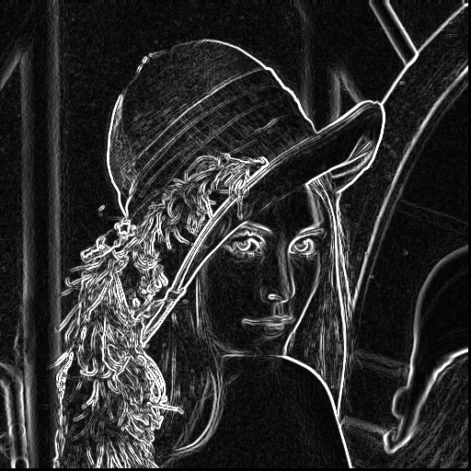

Edge operator

Original image Edge image

利用threshold = 36

來取得二值化影像。

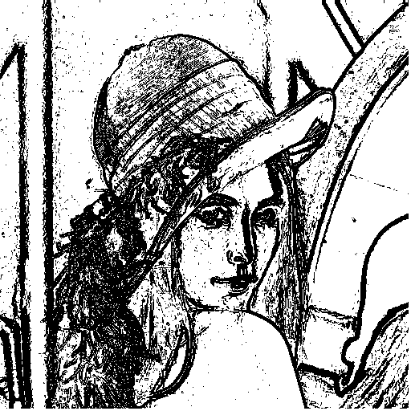

Sobel's Operator Edge image

**\* Frei and Chen’s Gradient Operator Concept \***

When processing the gradient image, there should be a value which you used for zero crossing. -> Frei and Chen’s Gradient Operator with threshold 30 : two 3X3 masks in row column direction

利用每點影像的像素值和 mask 分別相乘，達到邊緣偵測的結果值，在依照 gradient 定義把影像值寫回入新的影像矩陣中。利用『im2double』將原本 Lena 影像中的每點像素轉換成 doubles，方便和 mash 數值做運算。最後的 threshold 判斷將影像變成『二值化』的步驟即可求得最後結果。這裡和上一個 operator 運用到的概念幾乎一樣，唯一差別在 mash 的值。

**Source code**

%Frei and Chen's Gradient Operator

function FCG = Frei_and_Chen(image4,threshold)

image4 = imread('lena.bmp');

b = im2double(image4);

[m,n] = size(image4);

newimage_robert = zeros(size(image4));

threshold = 30;

% Frei and Chen's Gradient Operator

L(1:m,1:n) = 0;

for I = 1 : m-3;

for j = 1 : m-3;

r1=-1*b(i,j)-sqrt(2)*b(i,j+1)-1*b(i,j+2)+0+0+0+1*b(i+2,j)+sqrt(2)*b(i+2,j+1)+1*b(i+2,j+2);

L(i,j) = r1 * r1;

end

end

M(1:m,1:n) = 0;

for I = 1 : m-3;

for j = 1 : m-3;

r2 = -1*b(i,j)+0+1*b(i,j+2)-sqrt(2)*b(i+1,j)+0+sqrt(2)*b(i+1,j+2)-1*b(i+2,j)+0+1*b(i+2,j+2);

M(i,j) = r2*r2;

end

end

for i=1:m-3;

for j=1:m-3;

gradient =sqrt(L(i,j)+M(i,j));

newimage_robert(i,j)= gradient;

end

end

figure;

imshow(newimage_robert);

imwrite(newimage_robert,'FCG.bmp')

figure;

FCG=imread('FCG.bmp');

[m,n]=size(FCG);

for i=1:m

for j=1:n

if FCG(i,j)>threshold

FCG(i,j)=0;

else

FCG(i,j)=1;

end

end

end

imshow(uint8(FCG)*255);

imwrite(uint8(FCG)*255,'FCG_thres.bmp')

end

**Result**

 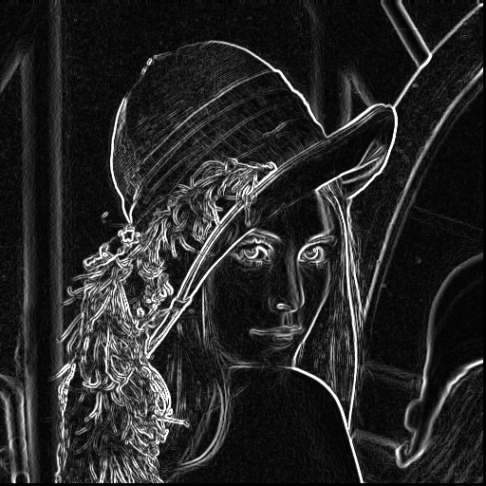

Edge operator

Original image Edge image

利用threshold = 30

來取得二值化影像。

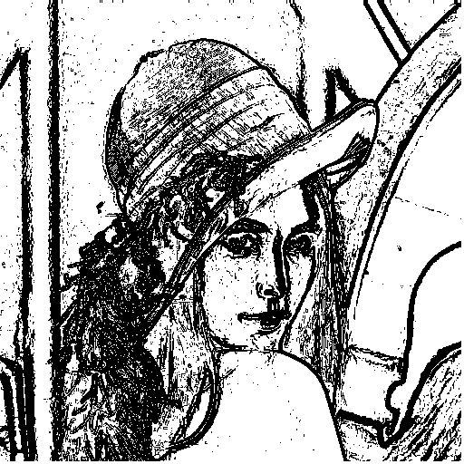

FCG's Operator Edge image

**\* Kirsch’s Compass Operator Concept \***

When processing the gradient image, there should be a value which you used for zero crossing. -> Kirsch’s Compass Operator with threshold 135 : eight 3*3 compass template edge masks

這裡和上一個 operator 運用到的概念不一樣，這裡將輸入 8 個 3*3 的 Mask 矩陣。Gradient 不再是 mask 乘上矩陣後值平方再開根號。而是將這八個 mask 分別去運算後找出最大的值(max)。

我利用到『imfilter』來分別將八的 mask 去和影像 lena 就運算;再利用『max』函式將運算最大值寫入新的影像矩陣中當作我們的輸出像素值。

**Source code**

function ks = Kirsch(image5,threshold)

image5 = imread('lena.bmp');

image5= im2double(image5);

threshold=135;

m = zeros(3,3,8);

m(:,:,1) = [-3 -3 5; -3 0 5; -3 -3 5];

m(:,:,2) = [-3 5 5; -3 0 5; -3 -3 -3];

m(:,:,3) = [5 5 5; -3 0 -3; -3 -3 -3];

m(:,:,4) = [5 5 -3; 5 0 -3; -3 -3 -3];

m(:,:,5) = [5 -3 -3; 5 0 -3; 5 -3 -3];

m(:,:,6) = [-3 -3 -3; 5 0 -3; 5 5 -3];

m(:,:,7) = [-3 -3 -3; -3 0 -3; 5 5 5];

m(:,:,8) = [-3 -3 -3; -3 0 5; -3 5 5];

Am=zeros(size(image5,1), size(image5,2),8);

for i=1:8

Am(:,:,i) = imfilter(image5,m(:,:,i));

end

Ak = max(Am,[],3);

figure;

imshow(Ak);

imwrite(Ak,'Kirsch.bmp')

figure;

Kirsch=imread('Kirsch.bmp');

[m,n]=size(Kirsch);

for i=1:m

for j=1:n

if Kirsch(i,j)>threshold

Kirsch(i,j)=0;

else

Kirsch(i,j)=1;

end

end

end

imshow(uint8(Kirsch)*255);

imwrite(uint8(Kirsch)*255,'Kirsch_thres.bmp')

end

**Result**

 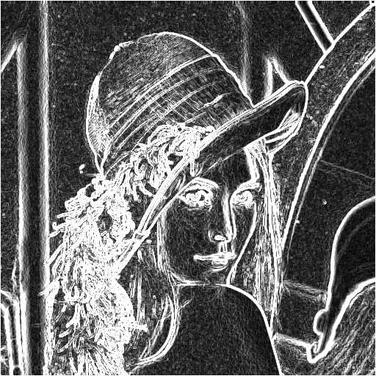

Edge operator

Original image Edge image

利用threshold = 135

來取得二值化影像。

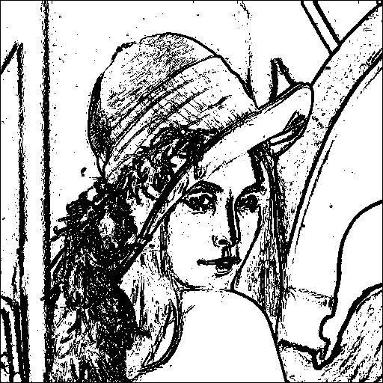

Kirsch's Operator Edge image

**\* Robinson’s Compass Operator Concept \***

When processing the gradient image, there should be a value which you used for zero crossing. -> Robinson's Compass Operator with threshold 45 : eight 3*3 compass template edge masks

這裡和上一個 operator 運用到的概念一樣，這裡一樣輸入8個 3*3的 Mask 矩陣。 將這八個 mask 分別去運算後找出最大的值(max)，作為 gradient。

**Source code**

function Robins = Robinson(image6,threshold)

image6= imread('lena.bmp');

image6 = im2double(image6);

threshold=45;

m = zeros(3,3,8);

m(:,:,1) = [-1 0 1 ; -2 0 2; -1 0 1];

m(:,:,2) = [0 1 2 ;-1 0 1 ; -2 -1 0];

m(:,:,3) = [1 2 1 ; 0 0 0 ; -1 -2 -1];

m(:,:,4) = [2 1 0 ; 1 0 -1 ;0 -1 -2];

m(:,:,5) = [1 0 -1 ; 2 0 -2 ;1 0 -1];

m(:,:,6) = [0 -1 -2;1 0 -1 ; 2 1 0];

m(:,:,7) = [-1 -2 -1 ;0 0 0 ; 1 2 1];

m(:,:,8) = [-2 -1 0 ; -1 0 1 ; 0 1 2];

Am=zeros(size(image6,1), size(image6,2),8);

for i=1:8

Am(:,:,i) = imfilter(image6,m(:,:,i));

end

Ak = max(Am,[],3);

%n = 255 / (max(Ak(:)) - min(Ak(:)));

%pic = uint8(n * Ak);

figure;

imshow(Ak);

imwrite(Ak,'Robinson.bmp')

figure;

Robinson=imread('Robinson.bmp');

[m,n]=size(Robinson);

for i=1:m

for j=1:n

if Robinson(i,j)>threshold

Robinson(i,j)=0;

else

Robinson(i,j)=1;

end

end

end

imshow(uint8(Robinson)*255);

imwrite(uint8(Robinson)*255,'Robinson_thres.bmp')

end

**Result**

 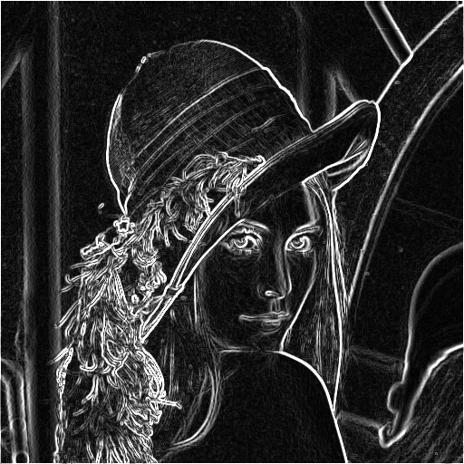

Edge operator

Original image Edge image

利用threshold = 45

來取得二值化影像。

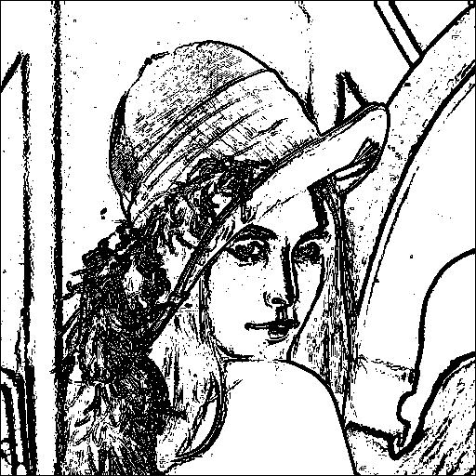

Robinson's Operator Edge image

**\* Nevatia-Babu 5x5 Operator Concept \***

When processing the gradient image, there should be a value which you used for zero crossing. -> Nevatia-Babu 5x5 Operator with threshold 155 : eight 3*3 compass template edge masks

0度 30度

60度 -90度

-60度 -30度

這裡和上一個 operator 運用到的概念一樣，這裡改成輸入 6 個 5*5 的 Mask 矩陣。將這六個 mask 分別去運算後找出最大的值(max)，作為 gradient。

這裡比較麻煩和上面不一樣，需要加上下面的程式碼，才能運作。

『n =(max(Ak(:)))/255; pic = uint8(n*Ak);』

(因為這裡的 gradient 和 contour direction 差 90 度。)

**Source code**

function Nev = Nevati(image7,threshold)

image7 = imread('lena.bmp');

image7 = im2double(image7);

threshold=155;

m = zeros(5,5,6);

m(:,:,1) = [100 100 100 100 100 ; 100 100 100 100 100; 0 0 0 0 0 ;-100 -100 -100 -100 -100 ;-100 -100 -100 -100 -100];

m(:,:,2) = [100 100 100 100 100 ; 100 100 100 78 -32; 100 92 0 -92 -100 ;32 -78 -100 -100 -100 ;-100 -100 -100 -100 -100];

m(:,:,3) = [100 100 100 32 -100 ; 100 100 92 -78 -100; 100 100 0 -100 -100 ;100 78 -92 -100 -100 ;100 -32 -100 -100 -100];

m(:,:,4) = [-100 -100 0 100 100 ; -100 -100 0 100 100; -100 -100 0 100 100 ;-100 -100 0 100 100 ;-100 -100 0 100 100];

m(:,:,5) = [-100 32 100 100 100 ; -100 -78 92 100 100; -100 -100 0 100 100 ;-100 -100 -92 78 100 ;-100 -100 -100 -32 100];

m(:,:,6) = [100 100 100 100 100 ; -32 78 100 100 100; -100 -92 0 92 100 ;-100 -100 -100 -78 32 ;-100 -100 -100 -100 -100];

Am=zeros(size(image7,1),size(image7,2),6);

for i=1:6

Am(:,:,i) = imfilter(image7,m(:,:,i),'same');

end

Ak = max(Am,[],3);

n =(max(Ak(:)))/255;

pic = uint8(n*Ak);

figure;

imshow(pic);

imwrite(pic,'Nevatin.bmp')

pic

figure;

Nevatin = imread('Nevatin.bmp');

[m,n]=size(Nevatin);

for i=1:m

for j=1:n

if Nevatin(i,j)>threshold

Nevatin(i,j)=0;

else

Nevatin(i,j)=1;

end

end

end

imshow(uint8(Nevatin)*255);

imwrite(uint8(Nevatin)*255,'Nevatin_thres.bmp')

end

**Result**

 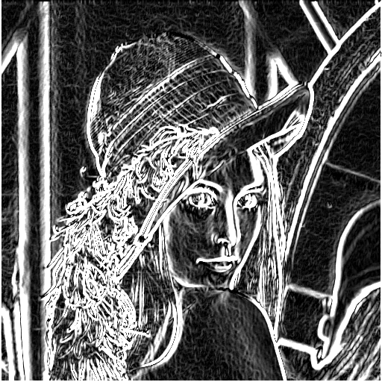

Edge operator

Original image Edge image

利用threshold = 155

來取得二值化影像。



Nevatin ‘s Operator Edge image